The 2017 Hyundai Ioniq is a small hatchback that comes as a hybrid, a plug-in hybrid, or an all-electric model; it's an important new player in the world of high-efficiency cars.
The 2017 Hyundai Ioniq is a compact five-door hatchback that breaks new ground among fuel-efficient cars by offering three separate powertrains: hybrid, all-electric, and plug-in hybrid. Several makers offer plug-in variants of conventional hybrids, but Hyundai is the first to add a battery-electric model that has no engine at all to its hybrid lineup. The Ioniq Hybrid comes in Blue, SEL, and Limited trim levels, while the Electric and Plug-In Hybrid versions offer base and Limited trims.
The Ioniq Hybrid will be the volume model, with distribution of the two versions with plugs limited to California and a handful of other states—though Hyundai pledges those two can be special-ordered by any dealer in the U.S.
In price and features, the hybrid Ioniq sits between the small, simple Toyota Prius C and the Prius Liftback. It slightly exceeds any version of the Prius in EPA fuel-economy ratings, and its appearance is far more conventional and less polarizing than any Prius. Other competitors for the Ioniq Hybrid include the Kia Niro hybrid wagon that shares its underpinnings, the Ford C-Max tall hatchback, and hybrid versions of several mid-size sedans, including its larger Hyundai Sonata stablemate, and the Ford Fusion, Kia Optima, and Toyota Camry.
Overall, we give the Hyundai Ioniq lineup a rating of 6.2 out of 10 points. That number may rise once safety ratings are in, as Hyundai has said it expects the Ioniq to receive top marks from both the NHTSA and IIHS. (Read more about how we rate cars this year.)
Normal design, performance
Hyundai notes survey data showing that buyers avoid hybrid and plug-in cars because they’re too expensive, they lack performance, and aren’t sporty enough. The Ioniq is intended to counter those concerns. Its design was intended from the start to be “normal,” effectively an anti-Prius, and it succeeds in camouflaging the high-tail shape that best reduces aerodynamic drag.
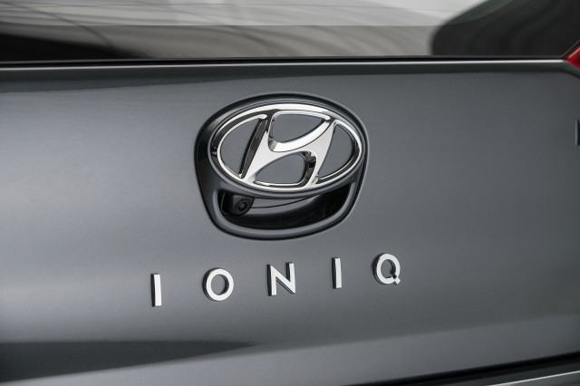
Inside, the Ioniq easily could be a Hyundai Elantra, with simple and pleasant shapes, intuitive and straightforward controls and instruments, and a healthy dose of conventional car appearance. The performance is decent, and the hybrid handles well, though the electric Ioniq makes do with a less-sophisticated rear suspension that reduces any sporty feeling. And the Ioniq Hybrid’s fuel-economy figures—a projected 58 mpg combined for the base Ioniq Blue, 55 mpg for other versions—is slightly better than comparable Prius models.
The Ioniq Hybrid starts around $23,000 including delivery, putting it right between the Prius C and Prius Liftback. What remains to be seen is whether the added cost of up to $5,000 more than a comparable Elantra in the same showroom will be justified by its efficiency in the eyes of buyers.
As for the two Ioniqs with plugs, the Ioniq Electric—rated at 124 miles of range—goes up against the 238-mile Chevrolet Bolt EV, the 107-mile Nissan Leaf, the 125-mile Volkswagen e-Golf, and the 114-mile BMW i3. Hyundai suggests that its energy efficiency, which is higher than any of those battery-electric cars, matters as much as range. It remains to be seen if buyers feel the same.
The Ioniq Plug-In Hybrid, which will arrive in the fourth quarter of 2017, will be positioned against the Chevrolet Volt, the plug-in Toyota Prius Prime, and perhaps plug-in hybrid models of the C-Max, Fusion, Sonata, and Optima.
To some degree, it feels as if the 2017 Ioniq range was finalized before the fourth-generation 2016 Prius hybrid or the 2017 Chevy Bolt EV electric car hit the market. Those two cars, with a known and trusted brand for the Prius and almost double the battery range for the Bolt EV, pose stiff competition to the new Ioniq—albeit at higher prices. The market will render its verdict on which approaches find buyers.
6

2017 Hyundai Ioniq

Styling

The 2017 Hyundai Ioniq isn't "weird" or "green" looking, but the result is an anonymous exterior with a straightforward and pleasant interior that evokes the Elantra compact.
The 2017 Hyundai Ioniq is a dedicated design, meaning there’s no gasoline-only version. (That’s where Hyundai's Elantra fits in.) The new Ioniq is deliberately designed to be conventional looking, or as “normal” as a high-tailed five-door hatchback with a low drag coefficient can be.
It leads off with Hyundai’s trapezoidal grille, flanked by headlights that sweep sharply back into the fenders, with LED lights in higher trim levels and versions. The windshield is steeply raked, but the body sides are flat, with a horizontal accent line that leads into conventionally shaped taillights. The horizontal rear lamps and some clever accent lines and curves keep the rear from looking nearly as tall as it is.
In other words, the Ioniq is no Toyota Prius or Nissan Leaf—to the point that it may pass unnoticed in traffic despite its advanced propulsion systems. We suspect that few people will look at an Ioniq and suspect that it has a hybrid or electric powertrain. Hyundai says the car has a drag coefficient of 0.24, among the lowest for production cars (proving that aerodynamic efficiency doesn’t have to look strange).
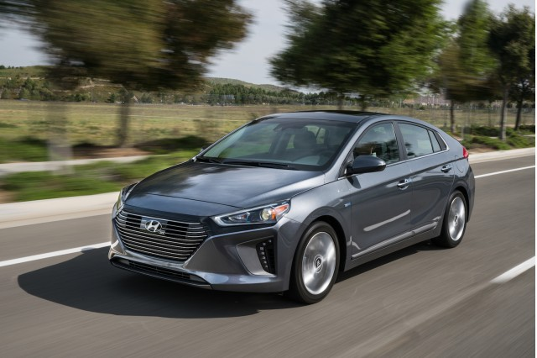
The interior is even more conventional, and could well have been an alternate design for that of the current Elantra. We've long been fond of Hyundai's straightforward shapes, intuitive controls, and generally handsome interiors, and the Ioniq doesn't disappoint on that front. The materials in the top versions of the Ioniq have substantial amounts of hard plastic and feel less special than equivalent Elantras, but the overall cabin is even more resolutely normal than the exterior.
Overall, we give the Hyundai Ioniq lineup 6 points out of 10 for its design. It's perfectly pleasant, and does well under the constraints it has to meet, but a couple of extra points for the good interior are partly offset by one point docked for the anodyne, even anonymous, exterior. (Read more about how we rate cars this year.)
6

2017 Hyundai Ioniq

Performance

The 2017 Hyundai Ioniq Hybrid performs and handles on a par with the latest Prius, but the Electric and Plug-In models are more pleasant.
The performance of the 2017 Hyundai Ioniq is really three separate topics, one for each of the three very different powertrains. The Ioniq Hybrid will be the high-volume version distributed nationwide, with the Ioniq Electric and the Plug-In Hybrid that arrives later this year more specialty vehicles for specific states (most notably California).
The Ioniq range overall is competitive, but not outstanding against its various competitors in the hybrid, electric, and plug-in hybrid segments. Its power output is only average for the category, though it feels notably faster than the larger, heavier Kia Niro Hybrid that shares its underpinnings. The challenge for the Ioniq Hybrid is that the (pricier) versions that can operate entirely or partly on electric-only power are simply smoother and more pleasant to drive. That said, Hyundai's done a good job of making the hybrid far smoother than even the best hybrids of five years ago.
We give the Ioniq range a rating of 6 out of 10, largely because the rating is weighted heavily toward the hybrid volume model. It would have earned a higher score before the 2016 Toyota Prius Liftback arrived, but that vehicle offered much better engine isolation and roadholding than any previous generations of the world's best-known hybrid—and consequently reset the bar. The rating might be higher if only the Ioniq Electric were being reviewed. (Read more about how we rate cars this year.)
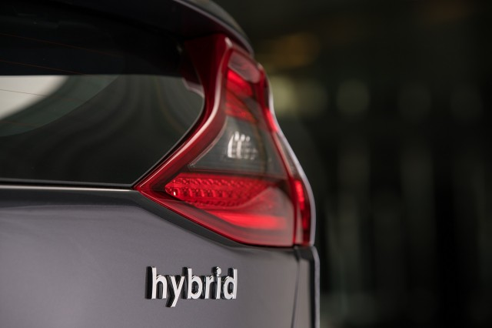
Highly efficient engine
The hybrid Ioniq is powered by a direct-injected 1.6-liter 4-cylinder engine that produces roughly 104 horsepower and 109 pound-feet of torque. Designed from the outset for hybrid application, it can reach a maximum thermal efficiency of 40 percent under certain circumstances. A single 32-kilowatt (43-hp) electric motor sits between that engine and a 6-speed dual-clutch automated transmission. Maximum output of the powertrain is 139 hp, and it drives the front wheels.
A 1.56-kilowatt-hour lithium-ion battery pack sits under the rear seat to recapture otherwise wasted energy, returning it to power the electric motor, which can supplement the engine torque or power the Ioniq by itself under light loads at low speeds. The electric motor mostly buffers the somewhat abrupt action of the DCT, though the delivery of electric power while the transmission shifted seemed to leave a short lag a few times. We noted that the Ioniq Hybrid has no "EV" button to restrict it to electric operation only. In the end, we decided it was better to ignore the car's hybrid powertrain and simply let it decide how and when to operate electrically.
The anticipated EPA ratings, however, show that it all works as designed: the base Ioniq Hybrid Blue earns a combined 58-mpg rating, better than the Prius Two Eco at 56 mpg combined. Similarly, the rest of the Ioniq Hybrid range comes in at 55 mpg combined, better than the 52-mpg figure for the rest of the hybrid Prius range.
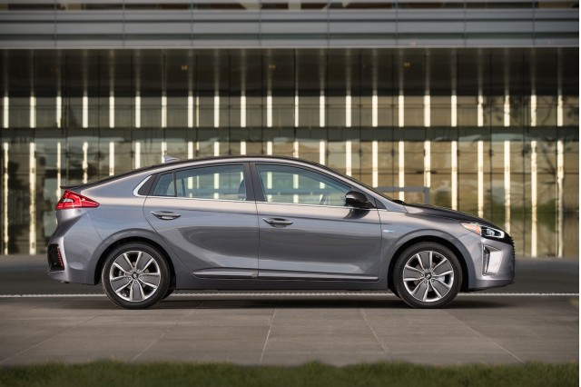
The Ioniq Plug-In Hybrid will use a similar powertrain, but with a more powerful electric motor of 45 kw (60 hp) to give it better electric-only performance. Its 8.9-kwh battery pack is estimated to provide an all-electric range of 27 miles or more, though Hyundai stressed that it is still being certified and that number may change before it goes on sale late this year. Its onboard charger is rated at 3.3 kilowatts, for a complete recharge of roughly 2.5 hours from a 240-volt Level 2 charging station and 8 hours on standard household current.
The battery-powered Ioniq Electric differs from the pair of hybrids in several ways. For one, the grille is replaced by a blanking panel to distinguish it visually from the combustion-powered Ioniqs. Inside, Hyundai has replaced the conventional shift and parking-brake levers on the tunnel with a set of buttons and the controller for the interactive display in the center of the dashboard.
Intent: fun to drive
The all-electric version's 28-kwh battery pack provides a rated range of 124 miles via an 88-kw (118-hp) electric motor that is the car’s sole source of propulsion. The pack, however, is located under the rear seat, between the rear wheels, and under the load bay, rather than under the passenger compartment floor as in a Nissan Leaf—a design decision that lowers the car overall but cuts slightly into cargo space.
The electric Ioniq's onboard charger is rated at 6.6 kw, for a full Level 2 recharging time of about 4 hours, and it also comes standard with DC fast-charging capability using the Combined Charging System standard. Importantly, it can fast-charge at up to 100 kw, higher than any non-Tesla electric car, including the Bolt EV. That gives it a certain amount of future-proofing, for higher-speed fast-charging stations to be installed in the coming years.
Most cars this size aren’t used as family transport, but for one or two people—and Hyundai stresses that the Ioniq was designed to be fun to drive, offering more efficient transportation with “no compromises” in enjoyment. Hyundai notes that the low-mounted battery packs give all Ioniq models a low center of gravity, and that the suspension has been specially tuned to work with low-rolling-resistance tires on 15-, 16-, or 17-inch wheels.
The Hybrid and Plug-In Hybrid models use a multi-link rear suspension, which delivers roadholding that seemed roughly average across the entire range of compact cars, from high-volume Toyotas to sportier Mazdas. The Electric makes do with a simpler torsion-beam rear axle to leave more room for its larger battery pack, however, and we found it to bounce and wallow somewhat on hilly curves. We found the turning circle surprisingly tight, useful in crowded urban traffic.
The regenerative braking system is Hyundai’s third-generation system, said to offer better a blending of friction and regenerative brake force as the car slows. On that front, they've done a good job after starting well behind the curve for those 2011 models. The brake blending was seamless at virtually all times.
4

2017 Hyundai Ioniq

Comfort & Quality

The 2017 Hyundai Ioniq has straightforward, intuitive controls and a comfortable interior, but despite high interior volume numbers, the rear seat is tight for adults, especially taller ones.
The 2017 Hyundai Ioniq, among other design criteria, was intended to be a no-compromises green car. That translated to a "normal" appearance, standard controls, and plenty of interior volume and cargo space.
While Hyundai's accomplished all three in the various versions of the Ioniq, the way the interior space is distributed and apportioned contrasts significantly to a few of its rivals. This is a case where achieving the very highest efficiency numbers comes with a few compromises in packaging, despite the company's best efforts.
The Ioniq’s front seats are low but well-bolstered, with a seat height identical to the company's Elantra compact sedan, according to the company. That means the Ioniq is low but wide, and occupants sit fairly low in a world where growing numbers of the vehicles around it are taller crossovers, SUVs, and trucks.
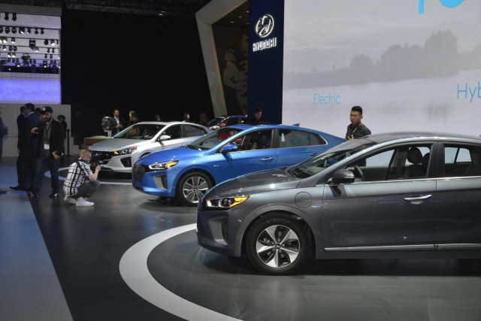
While the rear seat will accommodate two adults with adequate leg room, those adults won't be happy if they're on the tall side. The gradually sloping roofline and the battery positioning under the rear seat compromise rear head room. While Hyundai says the Ioniq Hybrid has 96.2 cubic feet of passenger volume—more than the Prius, though less than the Kia Niro or Ford C-Max—it's devoted more to front-seat riders than adults riding in the rear. Passengers in the rear seat get decent leg and shoulder room, but that's as far as it goes.
The front seats have various cup holders, trays, bins, and cubbies for holding small items, something Hyundai's done well recently. Cargo volume in the Ioniq Hybrid is 26.5 cubic feet, more than the Ford C-Max and Kia Niro, but less than that of all but one Prius Liftback model. The Ioniq Electric and Plug-In Hybrid has 23.8 cu ft of cargo volume, more than the Chevy Bolt EV, Ford C-Max Energi, and Nissan Leaf, and its passenger volume beats all except the plug-in C-Max.
Hyundai's done a fairly good job suppressing noise, which has been a problem in earlier hybrid cars. While you'll notice the engine revving, it's not intrusive, and the 6-speed dual-clutch automated transmission limits the "motorboating" engine howl under maximum power.
Several of the interior materials incorporate recycled or sustainable materials, including plastic door covers whose material includes volcanic stone and powdered wood. They feel different than standard plastic, and in the interests of light weight, the Ioniq has rather more hard plastic than you might expect in its more expensive models, especially the Electric that runs upward of $30,000.
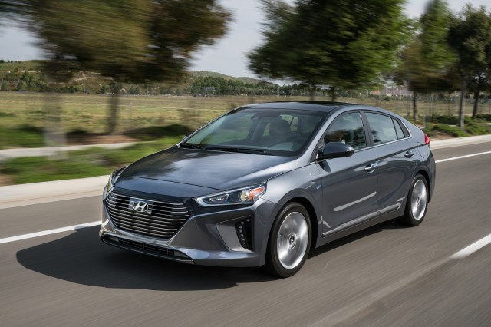
Overall, we rate the Ioniq range at 4 points out of a possible 10. Starting at the average of 5, it loses one for the minimal rear-seat head room. Its very capable noise suppression and lack of "motorboating" within the hybrid segment should be noted by potential buyers. (Read more about how we rate cars this year.)

2017 Hyundai Ioniq

Safety

Hyundai expects the 2017 Ioniq lineup to get the highest safety ratings from both the NHTSA and IIHS, but neither agency has released test results yet.
Neither the NHTSA nor the IIHS has yet released their safety scores for the 2017 Hyundai Ioniq, so we haven't rated the car yet. Hyundai says it expects the Ioniq lineup to receive the highest possible scores: a five-star overall rating from the NHTSA, and a Top Safety Pick+ from the IIHS. If it does, the Ioniq's overall score will likely rise. (Read more about how we rate cars this year.)
All versions of the 2017 Ioniq have seven airbags, a driver's blind-spot mirror, and a rearview camera as standard equipment. All but the base Ioniq Hybrid Blue have blind-spot monitors, and the SEL version of the Ioniq Hybrid offers a separate Tech Package that adds three active-safety features: lane-departure warning, adaptive cruise control, and automatic emergency braking.
All three versions of the Ioniq—Hybrid, Electric, and Plug-In Hybrid—offer an Ultimate Package on their top Limited trim only. That list of features includes the remainder of the available active-safety systems: the three included in the Hybrid's Tech Package, plus rear parking sensors, and swiveling headlights.
6

2017 Hyundai Ioniq

Features

The 2017 Hyundai Ioniq has decent standard and optional features for a green small car, but few of them stand out and active-safety features are optional.
The 2017 Hyundai Ioniq Hybrid, which will be the high-volume model distributed nationally, comes in Blue, SEL, and Limited trim levels. The Ioniq Electric and Plug-In Hybrid versions have base and Limited trims; they will be distributed in a limited group of states, but are available as a special order from any Hyundai dealer.
We rate the Ioniq lineup overall at 6 out of 10 points. Its standard and optional features are average for a compact car, though it has no unique features that stand out as exceptional. Its more sophisticated active-safety systems are optional, but only available at the highest trim level. (Read more about how we rate cars this year.)
Just five exterior colors are offered, along with black or tan interiors, but the tan interior is offered only on the hybrid—not the electric or plug-in hybrid—versions.
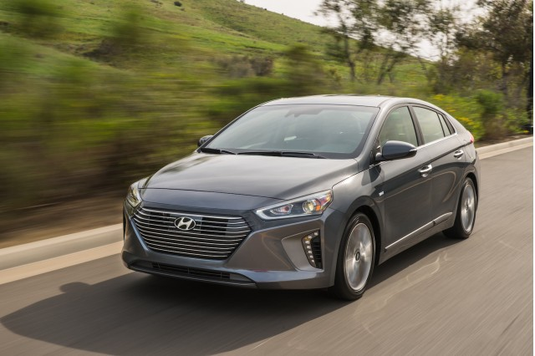
The base car, the Ioniq Hybrid Blue, comes standard with 15-inch alloy wheels, a Sport driving mode, keyless ignition, a 4.2-inch multi-function display in the instrument cluster, a 7.0-inch touchscreen for the audio system that includes Android Auto and Apple CarPlay, dual automatic climate control, six-way manually adjustable front seats, and a 60/40-split folding rear seat back. For safety equipment, it has seven airbags, a driver's blind-spot mirror, and a rearview camera as standard equipment.
The Ioniq Hybrid SEL adds LED daytime running lights and taillights, heated door mirrors, heated front seats, a power driver's seat, a 7.0-inch instrument cluster display, and blind-spot monitors with rear cross-traffic alert and lane-change assist. It also has a few more interior amenities, including a rear-seat armrest with cupholders, and a bit more chrome trim inside and out.
The Hybrid SEL offers a separate Tech Package as well, consisting of three active-safety features: adaptive cruise control, automatic emergency braking, and lane-departure warning.
The top-of-the-range Ioniq Hybrid Limited adds 17-inch alloy wheels, a power sunroof, leather seats, LED interior lighting, and BlueLink telematic services, as well as further trim embellishments.
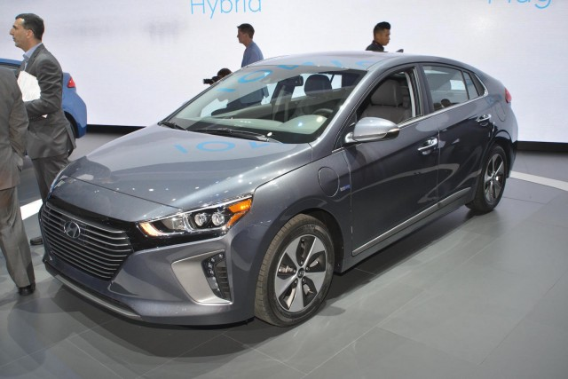
The base versions of the Ioniq Electric and Ioniq Plug-In Hybrid are roughly equivalent to the Hybrid SEL version, with the powertrain differences being the major changes as well as a few detail differences.
All three versions of the Ioniq offer an Ultimate Package on the top Limited trim only that includes several active-safety features—adaptive cruise control, lane-departure warning, automatic emergency braking, rear parking sensors, and swiveling headlights—plus memory for the driver's seat, a navigation system with 8.0-inch color touchscreen, an eight-speaker Infinity premium audio system, wireless device charging, and rear vents.
The Ioniq Hybrid was the first to arrive, with Ioniq Electric models arriving at California dealerships in April 2017, with a handful of other states to follow. The Ioniq Plug-In Hybrid will go on sale in limited states during the fourth quarter of 2017.
9

2017 Hyundai Ioniq

Fuel Economy

One version of the hybrid Hyundai Ioniq, which will sell more than the electric and plug-in hybrid versions, has the highest fuel economy of any vehicle without a plug.
As a dedicated vehicle with a choice of green (Ioniq Hybrid), greener (Ioniq Plug-In Hybrid), and greenest (Ioniq Electric) powertrains, the 2017 Hyundai Ioniq includes among its tricks an aerodynamically slippery shape, lightweight components, active grille flaps for the versions with engines, and predictive energy management for the electric model that adjusts for elevation along roads.
The base Ioniq Hybrid Blue model is expected to earn a combined 58-mpg rating, according to the manufacturer, which is better than the best Toyota Prius Two Eco at 56 mpg combined. Similarly, the rest of the Ioniq hybrid range comes in at a projected 55 mpg combined, better than the 52-mpg figure for the rest of the hybrid Prius range.
For those anticipated ratings, we give the Ioniq range 9 points out of 10. Electric and plug-in models would ace our scoring system, but the hybrid model will be by far the highest-volume version, so that's the one we rate. (Read more about how we rate cars this year.)
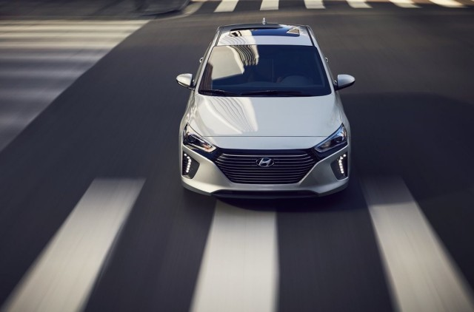
Complete ratings for the gasoline-powered Ioniq Hybrid Blue are 57 mpg city, 59 highway, 58 combined, with all other hybrid trim levels at 55/54/55 mpg. The company hasn't yet released projected efficiency figures for the Ioniq plug-in, which won't arrive at dealers until later this year.
As for the 2017 Ioniq Electric, it earns an EPA range rating of 124 miles—the highest on the market this year for any car that isn't either a Tesla (all 200-plus miles) or a Chevrolet Bolt EV (238 miles). It nearly equals the updated 2017 Volkswagen e-Golf, which is rated at 125 miles.
During its media promotion for the Ioniq lineup, Hyundai repeatedly suggested that the energy efficiency of electric cars is just as important as their rated range in miles. Indeed, the electric Ioniq's rating of 136 MPGe is higher than that of any other car with a plug in the U.S. this year. (Miles Per Gallon Equivalent, or MPGe, is the distance a car can travel electrically on the same amount of energy as contained in 1 gallon of gasoline.)
The electric version thus beats the Prius Prime plug-in hybrid's 133 MPGe when operating in electric mode and the 124 MPGe of the most efficient version of the BMW i3. The challenge is that even the least efficient plug-in electric car uses energy more efficiently than any non-plug-in vehicle with a gasoline or diesel engine. Whether buyers will focus on more efficient energy use over range remains to be determined.

